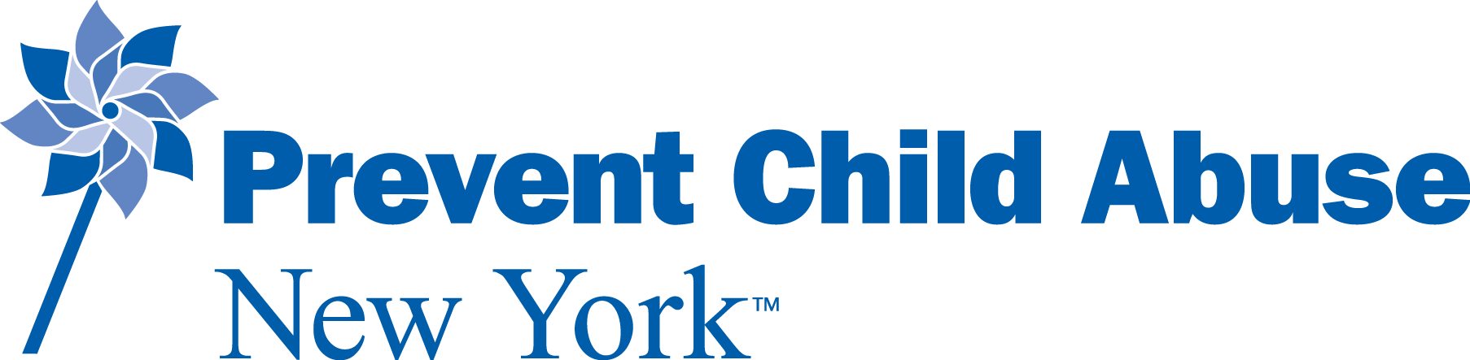

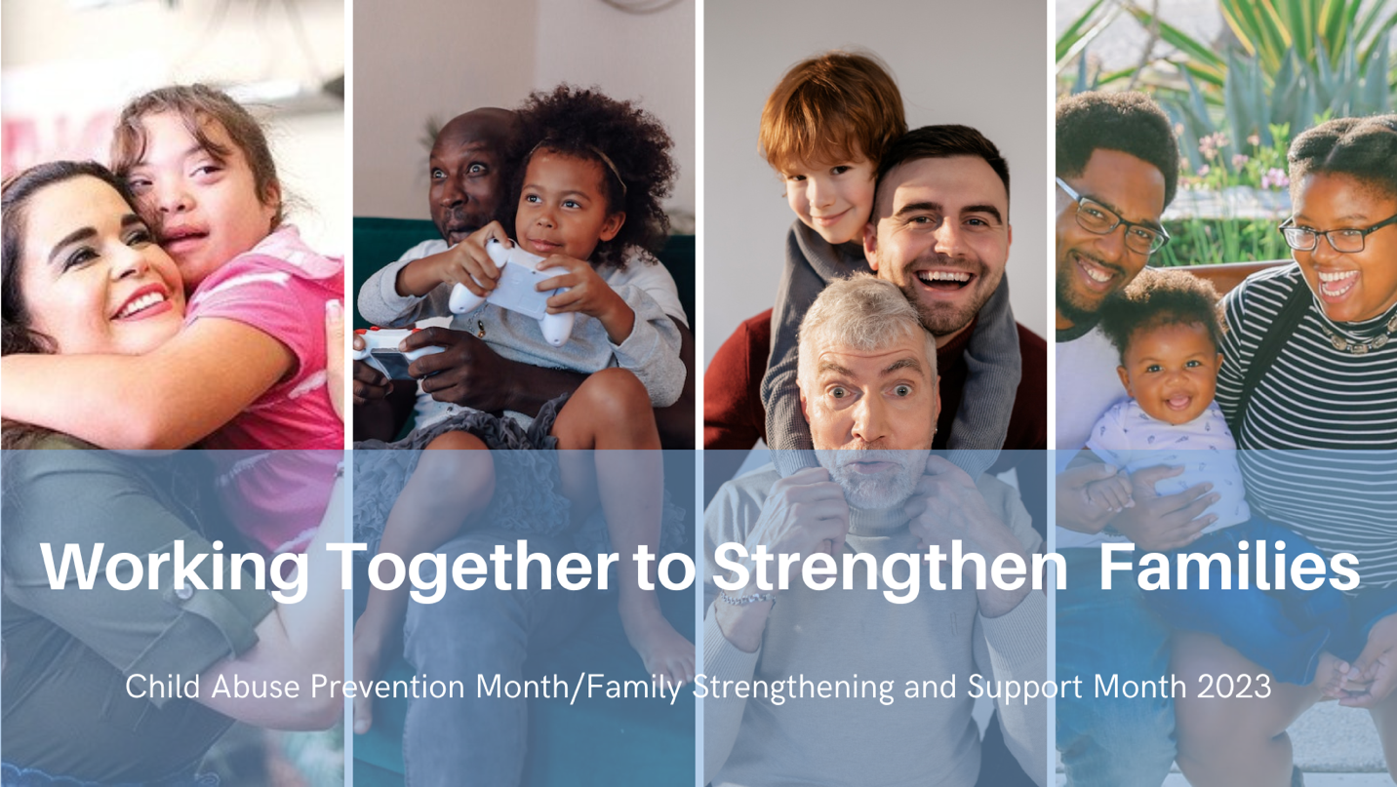

Child Abuse Prevention (CAP)/
Family Strengthening and Support Month Toolkit

2023
Introduction

We are getting ready to launch Child Abuse Prevention Month 2023 on April 1st, and we would love for you to be a part of it. The monthlong campaign allows us to promote simple actions that can make a big difference in the lives of children by strengthening families and communities. We can prevent child abuse by removing and challenging barriers to healthy parenting. Your involvement shows families in your community that they are supported not just by agencies, organizations, schools, and churches, but by their community as a whole. To that end, we are beginning a shift to Family Strength and Support Month, to reflect our goal of addressing problems before they start.

Our theme for 2023 is “Working Together to Strengthen Families.” Throughout CAP Month we will be focusing on what communities can do to strengthen and support families. A strong, supportive community that values parenting and families makes a safe and healthy environment for kids. And parents who know they have support and access to resources are better parents. A strong community helps parents learn, supports them and reduces stress through programs and services that emphasize Protective Factors.
​
We are inviting you to be a part of our campaign, as a first step towards becoming a Prevention Champion. You can become a Prevention Champion by participating in CAP Month in one or more of the following ways:

- Follow us on social media. You can find us on Facebook, Twitter, Instagram, LinkedIn, and TikTok. Follow, like, and share to stay updated on CAP Month events and our work to end child abuse in New York State.
- Wear blue and share a selfie on social media. Help us turn social media blue on March 31st (National Go Blue Day) and April 3rd (Go Blue Day in NYS). Wear blue to show your support for New York's children and families, take a selfie, and share it on social media with the hash tags #GoBlueDay2023 #GoBlue4NYKids. We encourage you to share your pics on our social media sites too. New this year!!! Blue CAP Month t-shirts are available through the Prevent Child Abuse America Webstore for you to wear for these #GoBlueDay events!
- Plan a CAP Month event and share it. Whether it is a press conference, a pinwheel garden, a baby shower to collect items for parents in need, or a walk to raise awareness, let us know! Pinwheels can be ordered through Prevent Child Abuse America. Send photos of your event to Wendi Brandow. We will include your event in our promotions throughout the month and send you a Prevention Champion certificate at the end of the month.
- Invite someone from our Speaker's Bureau to discuss prevention, Protective Factors, and CAP Month in an article, on a talk show/podcast, or in person at a CAP Month event. For more information, contact Wendi Brandow.
- Schedule a training through our Resilience Leadership and Learning Institute. A variety of trainings are available through the Institute. Contact Tamae Memole for more information or to schedule a training. You can see a list of our offerings at www.rlli.org.
- Learn more about Protective Factors to support families in your community. Visit our website for more information on ways to support families, reduce stress, and decrease the likelihood of abuse occurring.
We are asking that everyone who takes part in CAP Month activities to please, once again, send us your schedule of events beforehand so that we can add them on our CAP Month calendar to be shared with all of our partners. Please click HERE to submit your events. These events may include a pinwheel garden, a press conference, or other community events.
​
Additionally, please send us pictures of your event and tag us in your social media posts to become a 2023 Prevention Champion. Official hashtags for this year are

#GoBlue4NYKids2023
#CAPMonth2023
#FamilyStrengtheningAndSupport2023
#WorkingTogetherToStrengthenFamilies
​
We would also love to share any press/media from your event.
​
As a thank you for full participation, we will send you a 2023 Prevention Champion certificate. Please submit your digital participation form by clicking HERE. Please send links of any media coverage or event pictures directly to Wendi Brandow, Communications Coordinator, at wbrandow@preventchildabuseny.org.

We hope this toolkit will assist you in making the most of your CAP Month 2023 outreach and activities. If you have any questions, please don’t hesitate to reach out to us.
​
Social Media

Please tag Prevent Child Abuse New York in any of your social media posts about/for CAP Month and Family Strengthening and Support Month. We are:

Facebook: @preventchildabuseny
Twitter: @PCA_NY
Instagram: @preventchildabuseny

Hashtags

Please use any or all of the following hashtags when posting on social media about CAP Month.

#GoBlue4NYKids2023
#CAPMonth2023
#FamilyStrengtheningAndSupport2023
#WorkingTogetherToStrengthenFamilies
​

​Talking Points

- Children are the foundation of a sustainable and productive society.
- All children have the right to safe, secure, and supportive environments.
- All parents and caregivers have the right to the support, resources, and knowledge that parenting demands.
- Child abuse prevention requires strengthening families and communities.
- We all have a part to play in creating stronger families and in turn, stronger communities.

Sample Social Media Images

Please contact Wendi Brandow for image files at wbrandow@preventchildabuseny.org

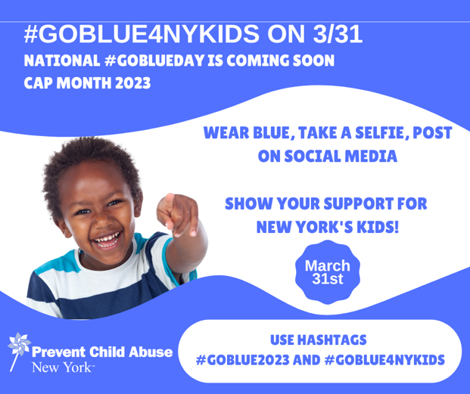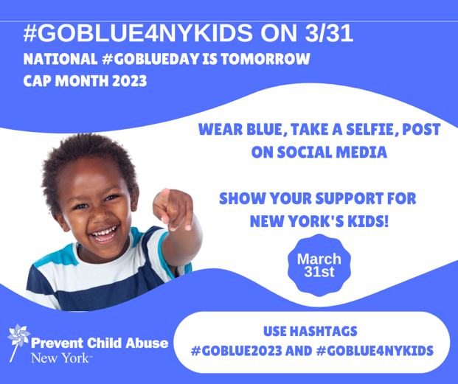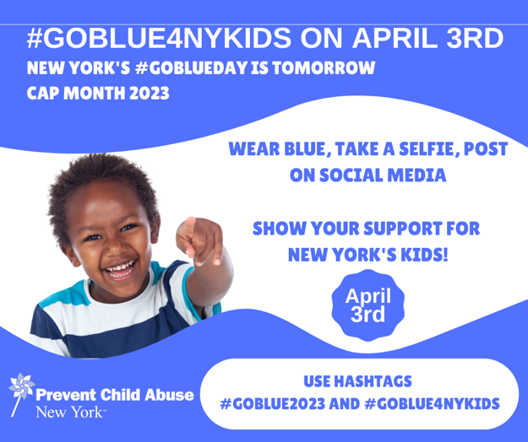

Boilerplate Language for Media Release

If you reference Prevent Child Abuse New York in a media release, please use the following language:

Prevent Child Abuse New York is the only private, nonprofit agency serving the entire state whose single mission is to prevent child abuse in all its forms. Our work is centered in prevention and, in particular, in those programs that address problems before they ever occur. This is referred to as “primary prevention.”

We remove barriers to healthy parenting through public awareness; training & technical assistance; and policy work & advocacy. Through our work we support the healthy development and prosperity of New York's children, families, and communities, since preventing child abuse often happens at the community level.

A strong, supportive community that values parenting and families makes a safe and healthy environment for kids. And parents who know they have support and access to resources are better parents.
​
A strong community helps parents learn, supports them and reduces stress through programs and services that emphasize Protective Factors.
​
We invite you to learn more about our work of strengthening families, because we all have a part to play in prevention.

Additional Resources

Additional resources can be found here:

Prevent Child Abuse New York
Prevent Child Abuse America

